LipidomeDB Data Calculation Environment Tutorial
Black = general information; Blue = pertinent to Pre-NL analysis only; Orange = pertinent to MRM analysis only; Purple = pertinent to CID-TOF analysis only

1. OVERVIEW, p. 3
1A. Introduction to Pre/NL and MRM analysis
1B. Introduction to CID-TOF analysis
1C. Lipid abbreviations

2. SAMPLE PREPARATION, DATA ACQUISITION, AND DATA OUTPUT FROM THE MASS SPECTROMETER, p. 6
2A. Extraction and sample preparation
2B. Internal standards
2C. Introduction of samples to mass spectrometer
2D. Pre/NL MS

2E. MRM MS

2F. CID-TOF MS

3. USE OF LIPIDOMEDB DCE FOR PRE/NL DATA, p. 13
Step 1: Assemble the data to be entered
Step 2: User log-in
Step 3: Enter data about the experiment
Step 4: Enter the first target compound set
Step 5: Enter any additional target compound sets
Step 6: Provide data about internal standard amounts in the Sample Info Sheet
Step 7: Upload the input data generated from the experiments in Excel format
Step 8: Collect the results

4. USE OF LIPIDOMEDB DCE FOR MRM DATA, p. 23
Step 1: Assemble the data to be entered
Step 2: User log-in
Step 3: Enter data about the experiment
Step 4: Upload the data
Step 5: Collect the results

5. USE OF LIPIDOMEDB DCE FOR CID-TOF DATA, p. 24
Step 1: Assemble the data to be entered
Step 2: User log-in
Step 3: Enter data about the experiment
Step 4: Enter the target fragment list
Step 5: Upload the input data generated from the experiments in Excel format
Step 6: Collect the results

6. THE COMPOUND AND FRAGMENT DATABASES AND EDITING OF SAVED TARGET LISTS, p. 28

7. OTHER CONSIDERATIONS ABOUT THE DATA, p. 28
7A. Inclusion of tissue metrics and other adjustments for Pre/NL or MRM data
7B. About the quantification for Pre/NL or MRM data
7C. About the quantification for CID-TOF data

8. ABOUT THE FUNCTION OF LIPIDOMEDB DCE (TECHNICAL INFORMATION), p. 29
8A. Languages
8B. Target lipid masses and isotopic variant fractions
8C: Data analysis algorithms for Pre/NL analysis
8D. Data analysis algorithm for MRM analysis
8E. Data analysis algorithm for CID-TOF analysis

1. OVERVIEW

1A. Introduction to Pre/NL and MRM analysis:
LipidomeDB Data Calculation Environment (DCE) contains tools to process data acquired after direct infusion of a lipid-containing biological extract, to which a cocktail of internal standards has been added, into an electrospray source of a tandem mass spectrometer. Multiple spectra from multiple samples may be processed simultaneously. The output is a table of amounts of specific lipid target compounds, determined by their mass spectral response in comparison to the internal standards. Data processing tools were originally created for the mass spectrometry-based lipid analytical approach using neutral loss (NL) and precursor (Pre) scans on a triple quadrupole MS (mass spectrometer/spectrometry), described by Brügger et al. [1997]. An update has provided data processing for data acquired by direct-infusion MRM (multiple reaction monitoring). This document explains the function of LipidomeDB DCE and provides example data and directions for LipidomeDB DCE.

LipidomeDB DCE has three phases: data collection, data analysis, and result output and collection. The following diagram shows the process.
Database
(LipidomeDB)

Data analysis

Result output and collection

Input data: Mass and signal list from Pre scans, NL scans, or MRMs

Target lipid and internal standard list(s)
Internal standard amounts

Data collection

Target lipids are the lipids to be analyzed. The input data, acquired by a triple quadrupole mass spectrometer, are either (1) spectral peak lists from Pre or NL scanning, in the Multiple Channel Analyzer (MCA) mode (a mode that averages or sums the signal from multiple scans to produce a spectrum) or (2) intensities from MRM transitions, which target pairs of an intact ion and a designated fragment for acquisition.

Data processing, including baseline subtraction, smoothing, and centroiding (integration), for Pre and NL scanning, are performed with the mass spectrometer’s acquisition software. Spectra or intensities of MRM pairs, as lists of m/z vs. signal (peak intensity), are exported from the acquisition program to Excel files for upload to LipidomeDB DCE. For Pre/NL acquisition, multiple spectra, targeting various lipids, from multiple samples can be uploaded simultaneously to LipidomeDB DCE, and the user specifies the lipids to be analyzed, i.e., the target lipids. For MRM acquisition, data on target lipids are organized and uploaded in a single file. LipidomeDB DCE has existing lists of target lipids from which the user can choose, or the user can create his/her own target lipid lists, which can be saved for his/her own use. Functions of LipidomeDB DCE include locating the data for the target lipids in spectral lists for Pre/NL data, isotopic deconvolution of the signal values to determine the signal attributable to each target lipid in both Pre/NL and MRM data, and calculation of the amount of each lipid in comparison to the internal standards. LipidomeDB DCE results are lists of target lipids and their molar amounts. The results can be viewed on the web or exported in an Excel file.

1B. Introduction to CID-TOF analysis:
Collision induced dissociation (CID)/time-of-flight (TOF) MS [Esch et al., 2007] uses a quadrupole/time-of-flight (QTOF) MS. A lipid extract is infused into a QTOF instrument, and either the quadrupole is turned off or it is adjusted to allow ions of a wide m/z range to enter the collision cell before TOF analysis. An example would be allowing all ions of m/z > 400 to enter the collision cell. If the ions are negatively charged, fatty acyl anions are major fragmentation products. The fragments are analyzed to identify and roughly quantify all fatty acyl chains present in the samples. This analysis can be performed with or without internal standard addition. Because the analysis is performed on a QTOF MS, which has high mass resolution, the chemical formulas of fragments can be identified, and fatty acyl anions with the same nominal m/z, but different chemical formulas, can be differentiated by small m/z differences.

A list of target fragment ions, e.g., a list of fatty acyl anions, is defined within LipidomeDB DCE in terms of fragment names and chemical formulas, which indicate m/z. The data are exported from the mass spectrometer’s acquisition software as lists of product ion fragments (m/z and intensity). The exported data are uploaded. LipidomeDB DCE matches fragment m/zs with those in the target list at a mass resolution specified by the user. The output is the intensities of each target fragment for each sample.

1C. Lipid abbreviations:
The conventions used for lipid abbreviations in the database of LipidomeDB DCE are shown in Table 1. They are based on the LIPID MAPS nomenclature [Fahy et al., 2005], but are modified to accommodate the specificity of structural definition obtained in triple quadrupole mass spectrometry via precursor or neutral loss scanning. The user may provide his/her own names for compounds that he/she enters.

Table 1: Lipid name abbreviations used in LipidomeDB DCE.
Lipid group | Example abbreviation | Abbreviation explanation
Monoacyl glycerophospholipids
digalactosylmonoacylglycerol | DGMG(18:3) | (Acyl carbons: acyl carbon-carbon double bonds*)
lysophosphatidic acid | LPA(18:1)
lysophosphatidylcholine | LPC(16:0)
lysophosphatidylethanolamine | LPE(16:0)
lysophosphatidylglycerol | LPG(18:2)
lysophosphatidylinositol | LPI(20:2)
lysophosphatidylserine | LPS(18:1)
monogalactosylmonoacylglycerol | MGMG(18:3)
Diacyl glycerolipids
diacylglycerol | DAG(34:6) | (Total acyl carbons: total carbon-carbon double bonds)
phosphatidic acid | PA(34:3)
phosphatidylcholine | PC(32:0)
phosphatidylethanolamine | PE(36:2)
phosphatidylglycerol | PG(34:1)
phosphatidylinositol | PI(38:4)
phosphatidylserine | PS(36:5)
digalactosyldiacylglycerol | DGDG(36:6)
monogalactosyldiacylglycerol | MGDG(34:6)
sulfoquinovosyldiacylglycerol | SQDG(34:3)
tetragalactosyldiacylglycerol | TeGDG(34:6)
trigalactosyldiacylglycerol | TrGDG(34:6)
Lipids containing an ether linkage
alk(en)yl,acyl glycerophosphocholine | ePC(36:4) | (Total alk(en)yl plus acyl carbons: total alk(en)yl plus acyl carbon-carbon double bonds (including any vinyl ether linkage))
alk(en)yl,acyl glycerophosphoethanolamine | ePE(36:2)
alk(en)yl,acyl glycerophosphoserine | ePS(38:4)
Sphingolipids
ceramide | Cer-d18:1(16:0) | (carbons and carbon-carbon double bonds of fatty amide; d18:1, i.e., sphingosine base, indicated)
ceramide phosphoethanolamine | PE-Cer(24:0) | (carbons and carbon-carbon double bonds of fatty amide, assuming d18:1 sphingosine base)
dihexosylceramide | DiHexCer-d18:1(12:0) | (carbons and carbon-carbon double bonds of fatty amide; d18:1, i.e., sphingosine base, indicated)
dihydrosphingomyelin | DSM(24:0) | (carbons and carbon-carbon double bonds of fatty amide, assuming d18:0 dihydrosphingosine base)
glycosylinositolphosphoceramide | GIPC(42:2)-3 | (carbons and carbon-carbon double bonds of sphingoid base + fatty amide)-number of hydroxyl groups in base plus acyl chain
hexosylceramide | HexCer-d18:1(12:0) | (carbons and carbon-carbon double bonds of fatty amide; d18:1, i.e., sphingosine base, indicated)
sphingomyelin | SM(18:0) | (carbons and carbon-carbon double bonds of fatty amide, assuming d18:1 sphingosine base)
Other
sterol ester | campesterol(18:3) | (Acyl carbons: acyl carbon-carbon double bonds)
*”Double bonds” can also indicate double bond equivalents, such as rings. “Extra” oxygen atoms in acyl chains are indicated by a “-O”; for example, oxophytodienoic acid is 18:4-O to indicate 4 double bond equivalents and 1 “extra” oxygen atom.
2. SAMPLE PREPARATION, DATA ACQUISITION, AND DATA OUTPUT FROM THE MASS SPECTROMETER

2A. Extraction and sample preparation:
Many extraction methods can be utilized to obtain lipids from biological samples. A commonly used method was described by Bligh and Dyer [1959]. Recently, a rapid method for extraction from plant tissues has been described [Shiva et al., 2018]. It is generally necessary to determine the amount of tissue or biological samples used for the extraction, but a method for determination of this tissue metric that does not interfere with obtaining a high quality lipid extract should be employed. For example, protocols that involve weighing of harvested wet tissue before extraction should be avoided, as lipolysis can occur while weighing. The Bligh and Dyer [1959] and Shiva et al. [2018] methods are excellent for extraction of phospholipids, but the user may wish to use other protocols for other lipid types. Once an extract is obtained, a good practice is to evaporate the solvent and re-dissolve the extract in 1 ml chloroform or other appropriate solvent. With a complex biological extract, an amount corresponding to approximately 5-50 nmol of lipid should be dissolved in solvent for mass spectrometry analysis. A suggested protocol is to combine a fraction of the sample and internal standard mixture (see next paragraph) with solvents, such that they are in a final mixture of chloroform/methanol/300 mM ammonium acetate in water (300/665/35) in a final volume of 0.4 to 1.2 ml, depending on your MS fluidics set-up. Ammonium acetate is a good additive that aids ionization in both positive and negative modes; this additive is necessary if the user plans to utilize the existing (pre-formulated) target lists in LipidomeDB DCE. (It is possible to use other additives or none and to upload your own target list(s). See sections below.)

2B. Internal standards:
Biological target lipids are quantified by comparison of the size of the target lipid peaks with those of internal standard(s). Internal standards are synthetic or purified compounds that are added to the sample before analysis. Internal standard concentrations should be accurately determined by traditional analytical methods, such as phosphate assay or gas chromatography of fatty acid methyl esters. One, two, or three internal standards from each target group (e.g., 20 internal standards to analyze 10 target groups with 2 standards per group) can be used for quantification in LipidomeDB DCE in the analysis of Pre, NL, or MRM data. Ideally, the internal standards should produce the same fragment by collision induced dissociation as the compounds of interest. Internal standards, appropriate for use with the pre-formulated target lists, are indicated in Table 2. It is good to use at least 2 internal standards for each target compound group, if appropriate standard compounds are available. The best quantification is obtained if the internal standard m/zs bracket the m/z range of the target lipids (the analytes). It is advisable to make samples containing only the internal standards to determine background signals for the target lipids. It is suggested that “internal standards only” samples be run at regular intervals throughout the experiment. The amounts shown in brackets in Table 2 are examples of appropriate amounts of internal standards; you will enter, as input data, the actual amount of internal standards in your analysis.

Note that pre-mixed internal standards are available from KLRC. See our website at https://www.k-state.edu/lipid/analytical_laboratory/prices/index.html (near the bottom of the page). Other mixtures that can be used as internal standards can be purchased from Avanti (see footnote b in Table 2).

For CID-TOF MS data analysis, internal standards are optional. If they are used, one or two internal standards are recommended. If the target fragments are fatty acyl anions, good choices would be complex lipids containing a single, uncommon fatty acid, such as PC(24:0) [di12:0] and/or PE(46:0) [di23:0].

Table 2: Examples of internal standards for targeted lipid analysis.

Target lipids (those in existing lists) | Internal standard 1 [clarificationª; typical amount used] | Internal standard 2 [clarificationª; typical amount used] | Internal standard 3 [clarificationª; typical amount used] | Source of internal standards
Animal lipids
LPC | LPC(13:0) [0.6 nmol] | LPC(19:0) [0.6 nmol] |  | Avanti^{b}
LPE | LPE(14:0) [0.3 nmol]^{c} | LPE(18:0) [0.3 nmol] |  | Avanti
LPG | LPG(14:0) [0.3 nmol]^{c} | LPG(18:0) [0.3 nmol] |  | Avanti
PA | PA(28:0) [di14:0; 0.3 nmol] | PA(40:0) [diphytanoyl; 0.3 nmol] |  | Avanti
PC, ePC, and SM | PC(24:0) [di12:0; 0.6 nmol] | PC(48:2) [di 24:1; 0.6 nmol] |  | Avanti
PE, ePE, and PE-Cer | PE(24:0) [di12:0; 0.3 nmol] | PE(46:0) [di23:0; 0.3 nmol] |  | Avanti; PE(46:0) by transphos-phatidylation of PC(46:0) (i.e., di23:0)^{d}
PG | PG(28:0) [di14:0; 0.3 nmol] | PG(40:0) [diphytanoyl; 0.3 nmol] |  | Avanti
PI | PI(34:0) [16:0,18:0; 0.2 nmol]^{e} |  |  | Avanti
PS and ePS | PS(28:0) [di14:0; 0.2 nmol] | PS(40:0) [diphytanoyl; 0.2 nmol] |  | Avanti
Plant lipids
DGDG | DGDG(34:0) [18:0,16:0; 0.5 nmol]^{e} | DGDG(36:0) [di18:0; 0.7 nmol]^{e} |  | Matreya^{b}
GIPC | MGDG(34:0) [18:0,16:0; 2 nmol]^{e} | MGDG(36:0) [di18:0; 0.4 nmol]^{e} |  | Matreya
LPC | LPC(13:0) [0.6 nmol] | LPC(19:0) [0.6 nmol] |  | Avanti
LPE | LPE(14:0) [0.3 nmol]^{c} | LPE(18:0) [0.3 nmol] |  | Avanti
LPG | LPG(14:0) [0.3 nmol]^{c} | LPG(18:0) [0.3 nmol] |  | Avanti
MGDG | MGDG(34:0) [18:0,16:0; 2 nmol]^{e} | MGDG(36:0) [di18:0; 0.4 nmol]^{e} |  | Matreya
PA | PA(28:0) [di14:0; 0.3 nmol) | PA(40:0) [diphytanoyl; 0.3 nmol] |  | Avanti
PC | PC(24:0) [di12:0; 0.6 nmol] | PC(48:2) [di 24:1; 0.6 nmol] |  | Avanti
PE | PE(24:0) [di12:0; 0.3 nmol) | PE(46:0) [di23:0; 0.3 nmol] |  | Avanti; PE(46:0) by transphos- phatidylation of PC(46:0) (i.e., di23:0)^{d}
PG | PG(28:0) [di14:0; 0.3 nmol) | PG(40:0) [diphytanoyl; 0.3 nmol] |  | Avanti
PI | PI(34:0) [16:0,18:0; 0.2 nmol)^{e} | PI(36:0) [di18:0; 0.2 nmol)^{e} |  | Avanti
PS | PS(28:0) [di14:0; 0.2 nmol) | PS(40:0) [diphytanoyl; 0.2 nmol] |  | Avanti
SQDG | SQDG(32:0) [di16:0; 0.1 nmol] ^{e} | SQDG(34:0) [18:0,16:0; 0.7 nmol]^{e} | SQDG(36:0) [di18:0; 0.2 nmol] ^{e} | Isolated from plants and hydrogenated
ªThe internal standards are indicated by the nomenclature shown in Table 1. The “clarification” indicates the individual acyl chains of the compounds. This is the information needed for ordering or preparation of the internal standards.
^{b}Avanti is Avanti Polar Lipids, Inc., 700 Industrial Park Drive, Alabaster, Alabama 35007-9105. Matreya is Matreya LLC, 168 Tressler Street, Pleasant Gap, PA 16823.
^{c}LPE(14:0) and LPG(14:0) are found in small amounts in some biological samples. To use these compounds as standards, use significantly more than present in the biological samples, so that the endogenous lipid amount is negligible.
^{d}Comfurius and Zwaal [1977].
^{e}PI, MGDG, DGDG, and SQDG standards can be purchased as hydrogenated compounds or can be prepared by hydrogenation of natural mixtures. Be sure to confirm, by mass spectrometry, that the standards are fully hydrogenated. Most hydrogenated compounds can be quantified by gas chromatography of the fatty acid methyl ester derivatives.

Note to Advanced Users: In some cases no standards are available with structures matching those of a lipid class or group of interest as analytical target compounds. In this case, LipidomeDB DCE offers the option (described in “Notes to Advanced Users” for Pre/NL scans and implicit in MRM analysis) of quantifying lipid compound target signals in comparison to standard compounds present in a different spectrum.

2C. Introduction of samples to mass spectrometer:
Unfractionated lipid extracts in appropriate solvent (see “Extraction and sample preparation” section above), containing appropriate amounts of internal standards, are introduced by continuous infusion into the electrospray ionization source of a triple quadrupole MS or QTOF MS. The sample may be introduced using an autosampler fitted with the required injection loop (e.g., a 1-ml loop) for the acquisition time. Alternative source set-ups, such as a chip-based electrospray source using small volumes and lower flow, or manual introduction, can also be employed.

2D. Pre/NL MS (This section specific for Pre/NL acquisition and data preparation; analogous MRM and CID-TOF information is in 2E and 2F, respectively):

Pre/NL acquisition information: MS settings for many animal phospholipids are included in Kilaru et al. [2010]. Mass spectrometer-specific settings (e.g., source voltage, source temperature, lens voltages, collision energy, and collision gas pressure) should be optimized for your instrument. Typical acquisition times for Pre/NL scans are 1 to 5 min per scan. Sequential precursor and neutral loss scans of the extracts produce a series of spectra with each spectrum revealing a set of lipid species containing a common fragment. In the examples shown in Table 3 for polar lipids, the fragment is a common head group fragment. The scans shown in Table 3 are appropriate for the existing (pre-formulated) target lists.

For additional directions for lipidomic analysis with Pre/NL scans on a triple quadrupole MS, see Shiva et al. [2013].

Table 3: Scan modes for the existing Pre/NL target compound lists.
Lipids  analyzed | Polarity | Ion  analyzed | Scan mode | References
Animal lipids
LPC  (lysophosphatidylcholine) | + | [M+H]⁺ | Precursors of m/z 184 | [Brügger et al., 1997]
LPE  (lysophosphatidylethanolamine) | + | [M+H]⁺ | Neutral loss of 141 | [Brügger et al., 1997]
LPG  (lysophosphatidylglycerol) | - | [M-H]⁻ | Precursors of m/z 153 | [Brügger et al., 1997]
PA (phosphatidic acid) | + | [M+NH₄]⁺ | Neutral loss of 115
PC (phosphatidylcholine), ePC (alk(en)yl-acyl glycerophosphocholine), and SM (sphingomyelin) | + | [M+H]⁺ | Precursors of m/z 184 | [Brügger et al., 1997]
PE (phosphatidylethanolamine), ePE (alk(en)yl-acyl glycerophosphoethanolamine) , and PE-Cer (ceramide phosphoethanolamine) | + | [M+H]⁺ | Neutral loss of 141 | [Brügger et al., 1997]
PG (phosphatidylglycerol) | + | [M+NH₄]⁺ | Neutral loss of 189 | [Taguchi et al., 2005]
PI (phosphatidylinositol) | + | [M+NH₄]⁺ | Neutral loss of 277 | [Taguchi et al., 2005]
PS (phosphatidylserine) and ePS (alk(en)yl-acyl glycerophosphoserine) | + | [M+H]⁺ | Neutral loss of 185 | [Brügger et al., 1997]
Plant lipids
DGDG (digalactosyldiacylglycerol) | + | [M+NH₄]⁺ | Neutral loss of 341 | [Isaac et al., 2007]
GIPC (glycosylinositolphosphoceramide) | + | [M+NH₄]⁺ | Neutral loss of 179
LPC  (lysophosphatidylcholine) | + | [M+H]⁺ | Precursors of m/z 184 | [Brügger et al., 1997]
LPE  (lysophosphatidylethanolamine) | + | [M+H]⁺ | Neutral loss of 141 | [Brügger et al., 1997]
LPG  (lysophosphatidylglycerol) | - | [M-H]⁻ | Precursors of m/z 153 | [Brügger et al., 1997]
MGDG (monogalactosyldiacylglycerol) | + | [M+NH₄]⁺ | Neutral loss of 179 | [Isaac et al., 2007]
PA (phosphatidic acid) | + | [M+NH₄]⁺ | Neutral loss of 115
PC (phosphatidylcholine) | + | [M+H]⁺ | Precursors of m/z 184 | [Brügger et al., 1997]
PE (phosphatidylethanolamine) | + | [M+H]⁺ | Neutral loss of 141 | [Brügger et al., 1997]
PG (phosphatidylglycerol) | + | [M+NH₄]⁺ | Neutral loss of 189 | [Taguchi et al., 2005]
PI (phosphatidylinositol) | + | [M+NH₄]⁺ | Neutral loss of 277 | [Taguchi et al., 2005]
PS (phosphatidylserine) | + | [M+H]⁺ | Neutral loss of 185 | [Brügger et al., 1997]
SQDG (sulfoquinovosyldiacylglycerol) | - | [M-H]⁻ | Precursors of m/z 225 | [Gage et al., 1992; Welti et al., 2003]

The Kansas Lipidomics Research Center (Welti group) at Kansas State University can supply data acquisition methods for the above scans for an Applied Biosystems API 4000 triple quadrupole mass spectrometer (Applied Biosystems, Foster City, CA) with an autosampler (LC Mini PAL, CTC Analytics AG, Zwingen, Switzerland). To obtain data acquisition methods, check the KLRC website (www.ksu.edu/lipid) or email welti@ksu.edu.

Pre/NL data output from mass spectrometer and preparation for LipidomeDB DCE: Initial data processing is performed using the mass spectrometer software. This processing can include background subtraction, smoothing, and centroiding or another type of peak integration to produce what we have called "signal" or peak intensity. It’s important to note that the inputs to LipidomeDB DCE are peak lists, rather than lists of individual spectral data points; i.e., each spectral peak should be represented by a single pair of m/z and signal values. The peak intensity data should be exported to Excel; the data need to be assembled in a specific Excel format for uploading to LipidomeDB DCE. All the peak data for each target lipid group should be in one file (i.e., all the spectral peak data with one common fragment, for up to 35 samples, should be in one file; all peak data for the next fragment, for up to 35 samples, should be in another file, etc.). In the Excel file, the integrated peak data for each sample should be on its own worksheet, and the tab should be labeled with the sample name or number. Each sample name or number should be unique. In each sheet, Cell A1 should be “Mass”, B1 should be “Signal”, A2 should be “0”, and B2 should be “0”. Cells A3 through A“n” should contain the m/z (mass) values of the precursor peaks from a Pre or NL scan. Cells B3….B“n” should contain the corresponding peak intensities (signals). The limit on the number of rows in each sheet of the upload file is 10,000. For an example upload file, click here. AB Sciex programmers have written a script, called “MultiplePeriodProcessing”, which exports data in the proper format; however, the format may be replicated manually or through other scripts.

Skip to Section 3 for continuation of information about use of LipidomeDB DCE for Pre/NL data.

2E. MRM MS (This section specific for MRM acquisition and data preparation; analogous Pre/NL and CID-TOF information is in 2D and 2F, respectively):

MRM acquisition information: Direct infusion MRM data acquisition with a triple quadrupole mass spectrometer is rapid, with acquisition times depending on lipid abundance and the number of reactions being monitored. Vu et al. [2014] describe acquisition of direct infusion MRM data. Acquisition parameters for many lipids on a Waters Xevo TQS MS can be found in the supplemental data of that paper (Method S5 and Table S5). However, mass spectrometer-specific settings (e.g., source voltage, source temperature, lens voltages, collision energy, and collision gas pressure) should be optimized for your instrument.

MRM data are a series of intensities, each associated with an intact ion-fragment pair. Internal standard intact ion-fragment pairs need to be included in the acquisition lists. A list of internal standards and their acquisition parameters is included in Vu et al. [2014], Table S8.

MRM data output from mass spectrometer and preparation for LipidomeDB DCE: The details of export of data from the mass spectrometer can vary depending on the mass spectrometer. For the Waters Xevo TQS MS, Waters has a process called “Spectrum Combine”, developed by Iggy Kass, to process and export MRM data (combined and averaged over the infusion) to Excel. For the Sciex 6500+ MS, the MRM data are moved from Analyst to MultiQuant and exported. Here is a link to a document describing this process.

A critical step in the MRM data analysis is preparation of the input file. An example input file can be found here. Here are notes on this file:
Row 1, Columns A to Z: Headings should be exactly as shown in the example file.
Row 1, Columns starting at AA: The word “Input” should be in a number of columns corresponding to the number of samples to be analyzed.
Row 2: The user may make explanatory entries in Row 2 as desired. In particular, the sample names should appear in Row 2, starting at column AA.
Column A, Row 3 downward: An arbitrary number unique to each lipid analyzed.
Columns B and C, Row 3 downward: Lipid formulas in B and lipid names in C. Formulas are for the uncharged (M) version of the lipid. Formulas can be used without lipid names. Lipid names can be used alone if the formulas are in the LipidomeDB DCE Compound database (see Section 6). If both formulas and lipid names are entered, formulas take precedence.
Column D, Row 3 downward: Indicate adduct used in the MS experiment from this list: [M+H]+, [M+NH4]+, [M+Na]+, [M-H]-, [M-CH3]-, [M+OAc]-, or [M+CHO2]-. The M mass, plus or minus the mass of the indicated ion, should correspond to the m/z used for intact ion data acquisition. The indicated charge (positive or negative) must correspond to the mode used for data acquisition.
Column E, Row 3 downward: The formula of the charged fragment. This needs to correspond to the m/z used for fragment ion data acquisition.
Column F, Row 3 downward: This column indicates which data will be considered as a group for isotopic deconvolution. If this column is empty or if all the entries are identical, all intensity data will be considered in the isotopic deconvolution algorithm. If components are physically separated, such as via a Differential Mobility Spectrometry (DMS) device (or chromatography), then unresolved components should be given the same designation here and resolved components should have different designations. Note that if both positive and negative modes are used, MRM pairs in the two modes should also have different designations. If you would like to skip isotopic deconvolution, you can do this by putting a different entry for each lipid analyte here. For example, you could number the analytes sequentially.
Columns G, I, and K, Row 3 downward: Internal standards to be used for each analyte are designated. The number should be the number for the internal standard in Column A. In the example MRM data upload file, “15” in G3 indicates that LPC(13:0) is one standard for LPC(16:1), and “16” in I3 indicates that LPC(19:0) is the second standard. Up to 3 standards (columns G, I, and K) can be used.
Columns H, J, and L, Row 3 downward: The amount of the standards in columns G, I, and K, respectively. The molar units used here (typically nmol) will be the units in the output file.
Column M, Row 3 downward: The possible entries in this column are “Line” or “Average”. “Average” is most commonly used with MRM data and is recommended. “Line” will draw a straight line through the internal standard data in a plot of Intensity/nmol vs m/z of the internal standard intact ions, determine the Intensity/nmol at the m/z of the analyte of interest, and use that value to calculate the nanomolar amount of analyte from its observed intensity. “Average” will average the Intensity/nmol of the internal standards and use this value to calculate the nanomolar amount of analyte from the observed intensity.
Columns N and O, Row 3 downward: Entries for the experimental intact ion m/z and charged fragment m/z used in the acquisition.
Columns P and Q, Row 3 downward: Leave these columns blank. The program is going to calculate these values based on the input compound formulas (or names) in columns B and/or C, the specified adduct in column D, and the charged fragment formula in column E.
Columns R through Z, Row 3 and downward: The user may leave these blank or enter other compound-specific information that he/she would like to have associated with the data. Examples of such information might include alternative compound names or acquisition parameters, such as collision energies.
Columns AA onward: The MRM intensity data.
There is no specific limit on the number of compounds or samples that can be processed together, and the practical limit of the server has not been thoroughly tested. As we gain more insight into the limit of the system, we will try to update this information.

It is important to have the columns to the right of the data and the rows below the data completely blank. Random entries in these locations will create errors.

Note: Sometimes it’s helpful to be able to parse chemical formulas into Excel cells when developing your MRM data upload file. Parsing makes it easier to add or subtract fragments. An Excel-based tool for parsing formulas (into stoichiometry of each element) is available here.

Skip to Section 4 for continuation of information about use of LipidomeDB DCE for MRM data.

2F. CID-TOF MS (This section specific for CID-TOF MS acquisition and data preparation; analogous Pre/NL and MRM information is in 2D and 2E, respectively):

CID-TOF acquisition information: Extracts dissolved in solvent, such as chloroform/methanol/300 mM ammonium acetate in water, are infused into an electrospray ionization (ESI)-QTOF MS, typically at 10 – 40 µL/min, and CID-TOF MS spectra are acquired. The TOF analyzer should be tuned for maximum resolution (such as 10,000 resolving power) and calibrated. Mass selection in the Q1 quadrupole should be turned off or set to pass a wide range of ions, such as m/z > 400. These precursor ions are subjected to CID. For analysis of fatty acyl anions (the most common application), this should be done in the negative mode.

CID-TOF data output from mass spectrometer and preparation for LipidomeDB DCE: Initial data processing is performed using the mass spectrometer software. Selection of background subtraction, smoothing, and centroiding parameters should be carefully considered to make data processing reproducible. For more information on choice of these parameters for a Micromass Q-TOF-2 tandem mass spectrometer, see Esch et al. [2007]. You may need to mass-correct spectra by locking on an appropriate known anion in the m/z region of interest.

The peak intensity data should be exported to Excel; the data need to be assembled in a specific Excel format for uploading to LipidomeDB DCE. All the target fragment data should be in one Excel file. In the Excel file, the integrated peak data for each sample should be on its own worksheet and the tab should be labeled with the sample name or number. Each sample name or number should be unique. In each sheet, Cell A1 should be “Mass”, B1 should be “Signal”, A2 should be “0”, and B2 should be “0”. Cells A3 through A“n” should contain the m/z (mass) values of the fragment peaks from a CID-TOF scan. Cells B3….B“n” should contain the corresponding peak intensities (signals). There is no limit on the number of sheets or the number of rows of data for CID-TOF MS analysis. For an example of the CID-TOF data format, click here.

Skip to Section 5 for continuation of information about use of LipidomeDB DCE for CID-TOF data.

3. USE OF LIPIDOMEDB DCE FOR PRE/NL DATA

Step 1: Assemble the data to be entered: The primary data are the lists of lipid compounds (both targets and internal standards) for which the spectral peak lists will be searched, the amounts of standards used in the experiment, and the spectral peak data. Secondary required pieces of information are mass tolerance and the search method to be used.

To illustrate the use of LipidomeDB DCE, we have assembled a set of example spectral peak data. These 6 files can be downloaded and employed to illustrate the use of the system. Each file contains Pre/NL MS data for the following samples: std1 (a sample containing only the internal standard mixture), mouse 1, mouse 2, mouse 3, mouse 4, and mouse 5 (samples containing extracted mouse lipids plus the internal standard mixture). Four of the 6 files each contain data for one specific set of target lipids, and two of the six files each contain data for two sets of target lipids. Download Pre/NL example data here. (Directions specific to the example data throughout the remainder of this document are in red print.)

Step 2: User log-in: Please log in if you know your ID/password. Please contact us by emailing David Johnson if you want to create an account in the system or if you forgot your ID/password. After logging in, from the MAIN MENU shown below, select Add Precursor/Neutral Loss Experiment. Information on the Add MRM Experiment choice is in Section 4. Information on the Add CID-TOF Experiment choice is in Section 5. Information on the Add or Edit Fragments, Add or Edit Compounds, Edit User-Saved Precursor/Neutral Loss Target Lists, and Add or Edit CID-TOF Interfaces choices is in Section 6.
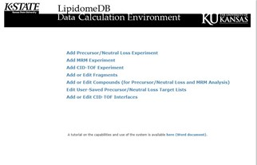
MAIN MENU

Step 3: Enter data about the experiment: As seen in the screenshot shown below, an experiment number is assigned by the database. Enter an experiment name, a description of the samples, and the number of target compound sets (enter 8 as the number of target sets for the example data). Mass Tolerance defines the m/z window for peak searching. We recommend 0.4 (mass units, u); this setting will locate peaks within 0.4 u above and below the theoretical m/z value for the designated ionized form of the target lipid compound. Mass to find provides for three options, Find the Largest Signal (within the m/z window designated by mass tolerance setting), Find the Nearest Mass (nearest to the theoretical m/z value of the designated ionized form of the target lipid compound), and Find the Sum of all Signals (a sum within the m/z window designated by mass tolerance setting). For most triple quadrupole MS data sets, it doesn’t make much difference which option you choose; we suggest choosing Find the Largest Signal. Click Continue.

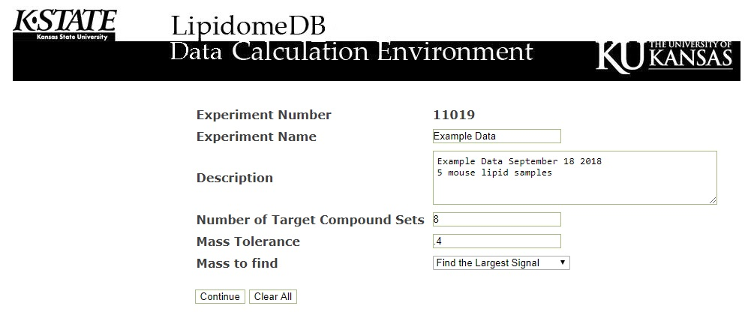

Step 4: Enter the first target compound set: The user can enter target lipids or choose from the existing lists.

a. Enter a target compound set from an existing (pre-formulated) list: The existing lists include molecular species from membrane polar lipid classes and are suitable for analysis of lipids derived from many plants and animals. If you are using the example data, under Select Existing, choose Animal LPC from the pulldown menu, as shown in the screenshot.
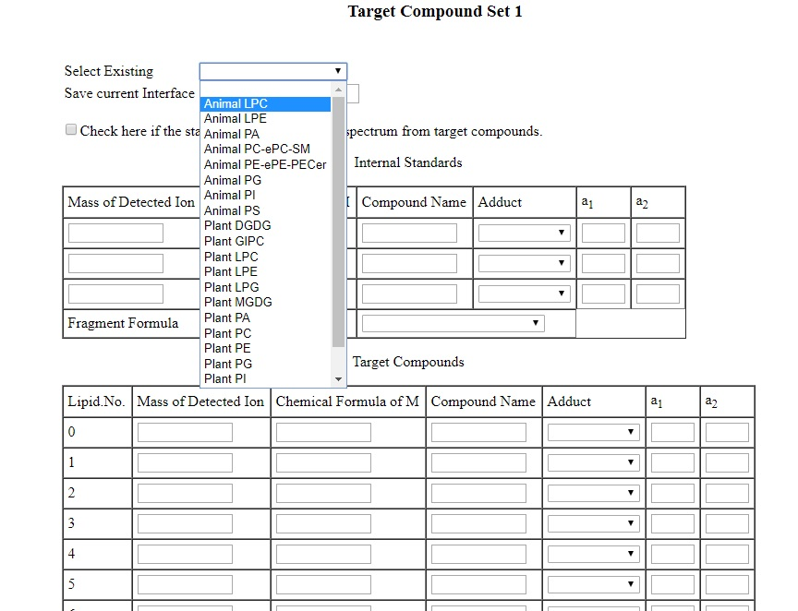

When you choose an existing list, then a new page will appear. See the screenshot below. Be patient and wait a few seconds for this sheet to appear before moving on.

Note to Advanced Users: If the standards that you will be using for quantification of the compounds in the target list are NOT in the same spectrum as the target compounds, check the box above the internal standard information. (Do not check this box if using example data.)

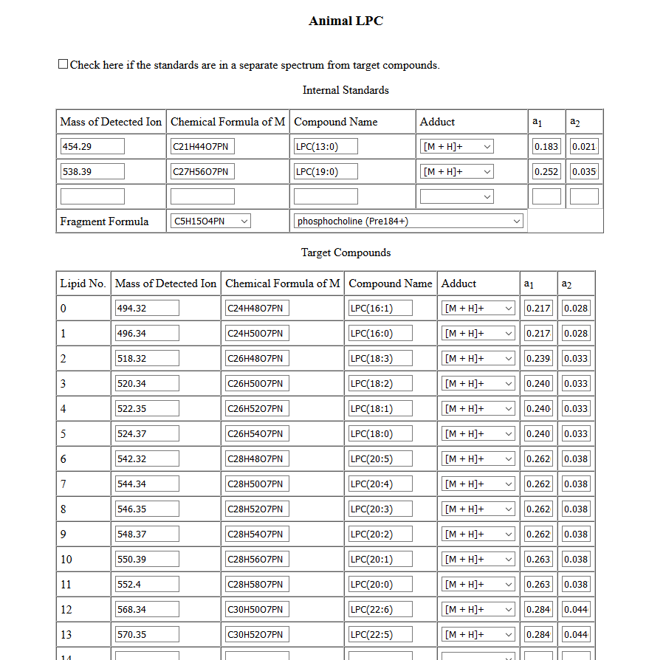
Check box if the standards are in a separate spectrum from target compounds.

Please note: You can modify the existing lists for one-time use, but cannot save them here. Added target compounds can be added at the end of the list and do not need to be in any particular order. By choosing Edit User-Saved Precursor/Neutral Loss Target Lists in the main menu, you can save an existing target list, not with the original name, but with a new name.

Scroll to the bottom of the page and press Continue. If using an existing (pre-formulated) list, go to Step 5.

b. Enter your own target compound set: You may indicate a fragment by using the drop-down list to choose an existing fragment name (which will retrieve the proper fragment formula). You also may add your own fragments by entering them right after log-in via the Add or Edit Fragments feature (see Section 6). If the fragment contains atoms that are added during formation of an adduct ion, these atoms need to be included in the fragment formula.

For the Internal Standards (1, 2, or 3 can be included) and Target Compounds (up to 99), you may enter either the abbreviated name of the lipid or the chemical formula of the M form (i.e., uncharged form) of the lipid. Target compounds do not need to be listed in any particular order. If a lipid is in the database (LipidomeDB), typing its abbreviation under Compound Name will retrieve the associated chemical formula. If a lipid is not in the database, entering the chemical formula and associated name is required. Elements that can be interpreted are C, H, N, O, P, and S. Chemical formulas should be entered as CmHnOqNrPsSt, where the large letters represent the elements and the small letters indicate the number of atoms of each element. Leaving an element abbreviation out of the formula indicates 0 atoms of that element, and no number following the element abbreviation indicates 1 atom of that element. The Mass of Detected Ion and a₁ and a₂ (relative amounts of A+1 and A+2 peaks, respectively) values will calculate automatically when the chemical formula is retrieved or entered.

Choose Adduct to indicate the form of the target compound that will be analyzed. (Choosing the Adduct should cause the Mass of Detected Ion, a₁, and a₂ values to adjust slightly.) Choices of adducts include, in the negative mode, [M – H]⁻, [M – CH₃]⁻, [M + OAc]⁻, and [M + CHO₂]⁻ and, in the positive mode, [M + H]⁺, [M + NH₄]⁺, and [M + Na]⁺. At this point, the Mass of Detected Ion should indicate the values for the targeted compound peaks in your spectrum.

Give Target Compound Set 1 a name, in the box near the top called Save current Interface, so that this target compound list will be available to you (but not to other users) in the future.

Please note: You can modify the existing lists, for one-time use, but you cannot permanently modify and save the pre-formulated lists or lists that you have previously entered in this location. To modify and save existing lists, you need to choose Edit User-Saved Precursor/Neutral Loss Target Lists in the main menu (Section 6).

Note to Advanced Users: If the standards that you will be using for quantification of the compounds in the target list are NOT in the same spectrum as the target compounds, check the box above the internal standard information.

When you have completed entering Target Compound Set 1, scroll to the bottom of the page and press Continue. Go to Step 5.

Step 5: Enter any additional target compound sets: Repeat Step 4 for the remaining target compound sets. Target compound sets can be all selected from the existing lists, all entered manually, or any combination.

If you are using the example data, choose the seven additional target compound sets, shown in Table 4.

Table 4: Existing lists to choose for example data.
Target Compound Set 2 | Animal PC-ePC-SM
Target Compound Set 3 | Animal LPE
Target Compound Set 4 | Animal PE-ePE-PECer
Target Compound Set 5 | Animal PA
Target Compound Set 6 | Animal PG
Target Compound Set 7 | Animal PI
Target Compound Set 8 | Animal PS

Press Continue at the bottom of the page to reach the Sample Info Sheet.

Step 6: Provide data about internal standard amounts in the Sample Info Sheet: Enter the amounts of each internal standard (in molar amounts, preferably in nmol) in the Sample Info Sheet. Data for up to 35 samples (labeled 0 through 34) can be entered. Each column thus should contain the internal standard amount data for one sample.

For the example data, fill out the Sample Info Sheet to look like the table below by entering the values (as shown in Table 2) of internal standards for each target compound set. If you enter a value for the first sample (sample “0”), the value will automatically fill across the rows for the other samples. If different amounts of internal standards were used in different samples, the automatically filled values can be over-written. Rows for internal standards that were not used should be left blank. Note that only one internal standard was used for PI in the experiment that produced the example data. It is OK to have values filled in for more samples (columns) than you have in your experiment.

When the Sample Info Sheet is complete, press Continue at the bottom of the page.

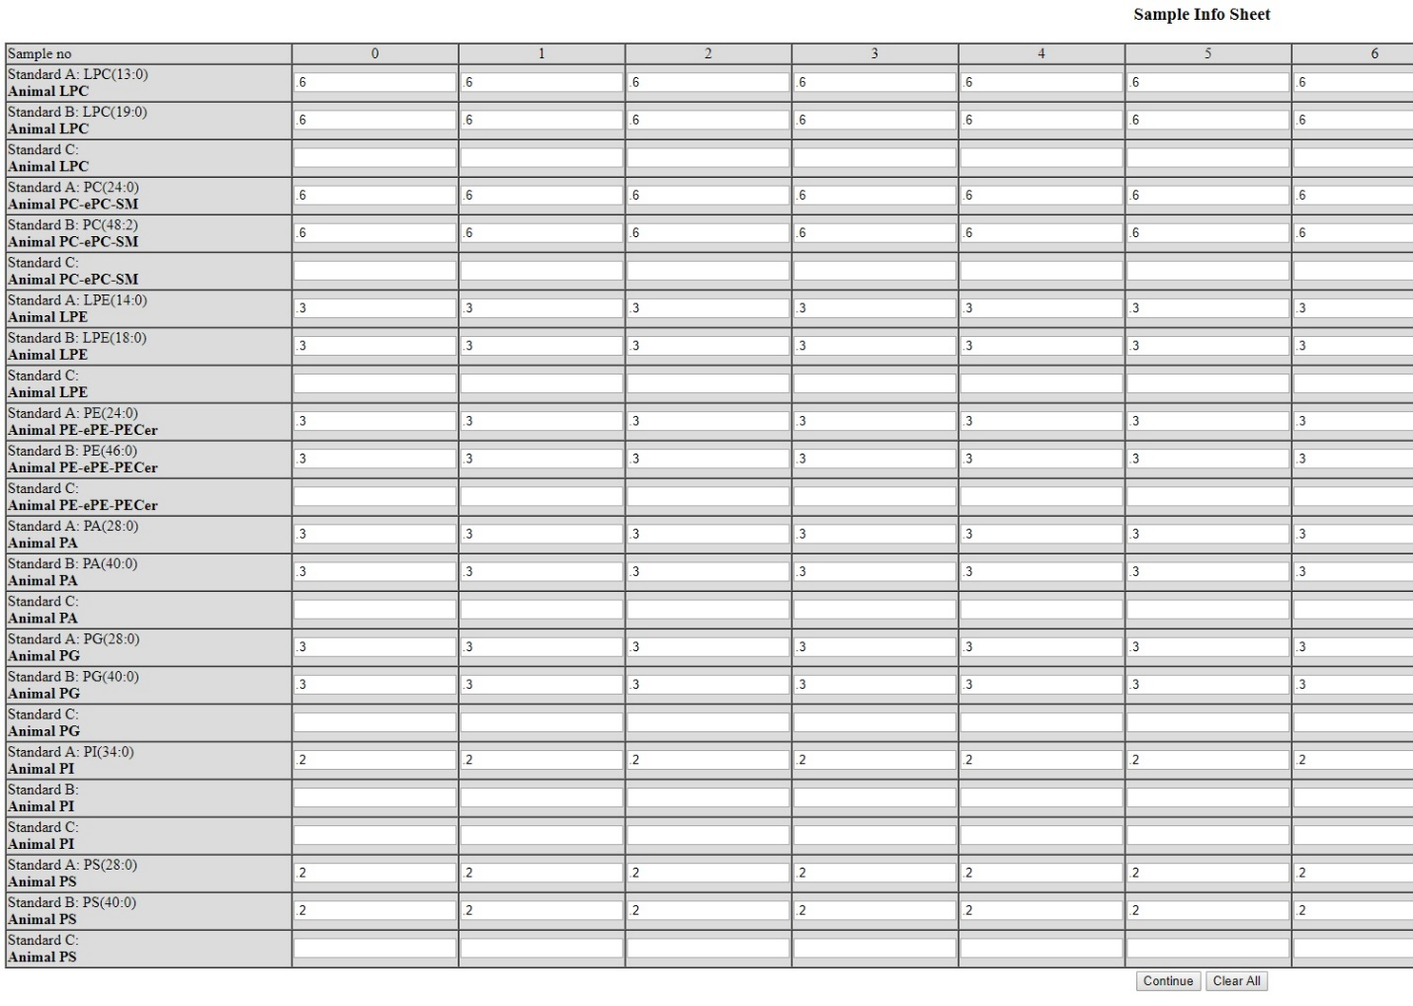

Step 7: Upload the input data generated from the experiments in Excel format: Upload an input file for each target list.

If you are using the example data, upload the files in the order shown in Table 5. Please note that Periods 2 and 3 contain data for more than one Target Compound Set and are each uploaded twice. Period 2 includes peaks for LPC and its LPC internal standards, as well as peaks for PC, ePC, and SM, all of which are being determined (in this example) in relation to the PC internal standards. Period 3 includes peaks for LPE and its LPE internal standards, and also peaks for PE, ePE, and PECer, all of which are being determined (in this example) in relation to the PE internal standards. When you have browsed and set the files for uploading, the page should look like the screen shot below the table. Press Continue.

Table 5: Example data files.
Target Compound  Set Number | Target Compound Set Name | File to upload | The scan used to generate the file (see Table 3)
1 | Animal LPC | Period2-LPC-PC-ePC-SM | Pre 184 (+)
2 | Animal PC-ePC-SM | Period2-LPC-PC-ePC-SM | Pre 184 (+)
3 | Animal LPE | Period3-LPE-PE-ePE-PECer | NL 141 (+)
4 | Animal PE-ePE-PECer | Period3-LPE-PE-ePE-PECer | NL 141 (+)
5 | Animal PA | Period4-PA | NL 115 (+)
6 | Animal PG | Period5-PG | NL 189 (+)
7 | Animal PI | Period6-PI | NL 277 (+)
8 | Animal PS | Period7-PS | NL 185 (+)

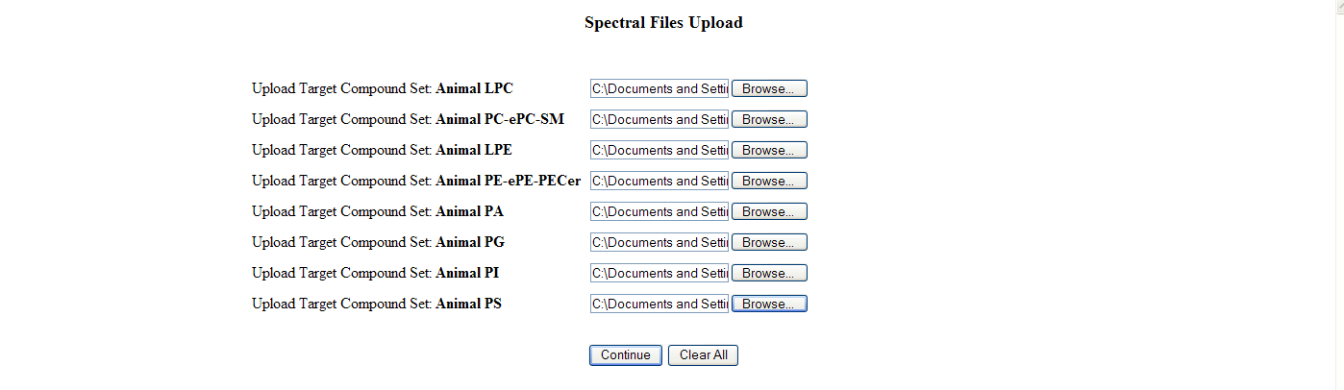

Note to Advanced Users: If you checked the box “Check here if the standards are in a separate spectrum from target compounds.” in the Target Compound Set sheet, additional upload boxes will appear here on the right for upload of a standard set corresponding to each target compound set.

Step 8: Collect the results: After the analysis is performed, the results can be viewed either on sheets containing data from individual samples or as a summary of all targeted compound sets. The following screenshot shows the (top of the) page from which you can navigate to three views of the data.

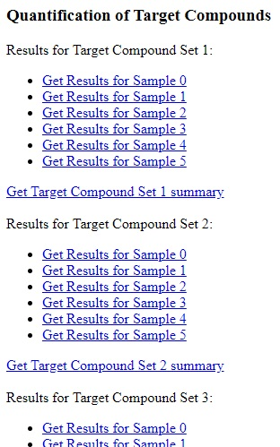

In Quantification of Target Compounds, clicking on Get Results for Sample 1 under Results for Target Compound Set 1 for the example data generates the view shown in the screenshot below. This screenshot shows the uploaded data (on the left) for one sample and shows the data (Mass Found and Signal) that were picked from the spectral peak data and used in the calculations of molar amounts. Corrected Signal shows the signals for each peak after isotopic deconvolution using the other peaks in the target list. (Note that this procedure assumes that the targeted lipids are the primary components of each Pre or NL scan. If there are non-targeted peaks near in m/z to the targeted ones, this isotopic deconvolution procedure may not be valid.) The last column, Amount (nmol), shows the amount of each targeted component in one sample, quantified in comparison to the internal standards. If the internal standard amounts were entered in nmol, then these values are in nmol. (Also see About the quantification for Pre/NL or MRM data (Section 7B) and Isotopic deconvolution (correction) of signal (Section 8C)).

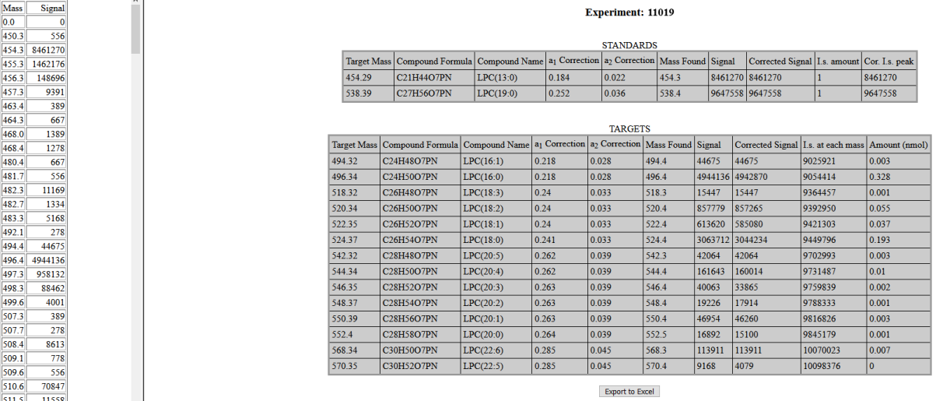
If a signal for one or more of the internal standards is not found, a warning will appear on the page that appears after choosing Get Results for Sample x: “One or more standards not found” (see screenshot below).

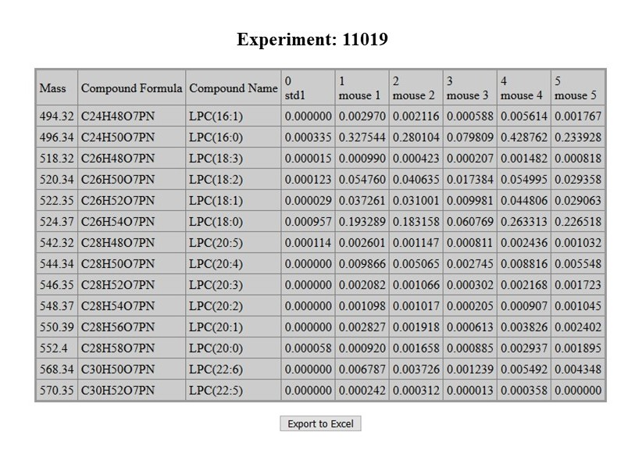
In Quantification of Target Compounds, clicking on Get Target Compound Set 1 summary for the example data generates the view shown in the screenshot below. This screenshot shows the amounts of each component in one target compound set, quantified in comparison to the internal standards, for all samples. If the internal standard amounts were entered in nmol, then the calculated values are in nmol. The target compounds are in rows, and individual samples are shown in columns.

[Note: If all the target compounds in any one sample column are listed as 0, please check the individual “Get Results for Sample x” sheets to see if the internal standards were detected; if internal standards are not detected, all compounds may be calculated as 0 or not calculated at all.]

In Quantification of Target Compounds, scrolling to the bottom of the page and clicking on Get Complete results summary for the example data generates the view shown in the screenshot below. This screenshot shows the amounts of each component for all target compound sets, quantified in comparison to the internal standards, for all samples. If the internal standard amounts were entered in nmol, then these values are in nmol. Again, the different samples are shown in columns.

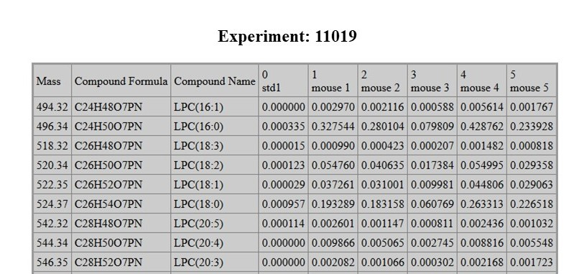

Scrolling down……

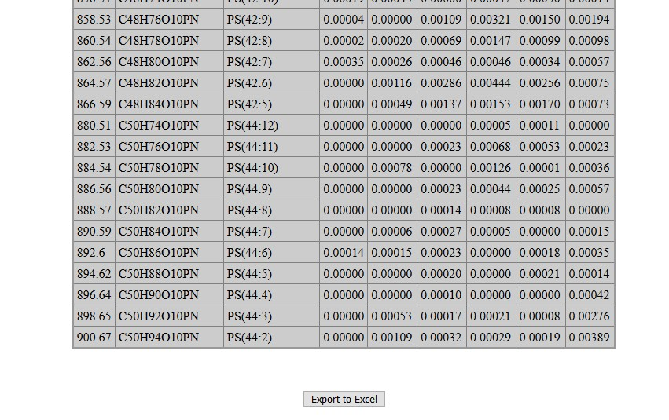

All results can also be exported in Excel format for offline analysis. There is a button at the bottom of each Results page to export the data. Exporting the Complete Results Summary of the example data will produce an Excel file like this. Note that you can convert the text format of the numbers to ordinary numbers by highlighting the block of numbers with the mouse, which makes a tab appear in the upper left corner, where you can choose “Convert to number”.

4. USE OF LIPIDOMEDB DCE FOR MRM DATA

Step 1: Assemble the data to be entered: The required information and format are described in Section 2E; data need to be arranged as in the MRM example data upload file. This example file contains MRM MS data for the following six samples: Internal standards only (a sample containing only the internal standard mixture), Mouse1, Mouse2, Mouse3, Mouse4, and Mouse5 (samples containing extracted mouse lipids plus the internal standard mixture).

Step 2: User log-in: Please log in if you know your ID/password. Please contact us by emailing David Johnson if you want to create an account in the system or if you forgot your ID/password. After logging in, select Add MRM Experiment. Information on the Add Precursor/Neutral Loss Experiment choice is in Section 3. Information on the Add CID-TOF Experiment choice is in Section 5. Information on the Add or Edit Fragments, Add or Edit Compounds, Edit User-Saved Precursor/Neutral Loss Target Lists, and Add or Edit CID-TOF Interfaces choices is in Section 6.

Step 3: Enter data about the experiment: As seen in the screenshot shown below, an experiment number is assigned by the database. Enter an experiment name and a description of the samples. Click Continue.
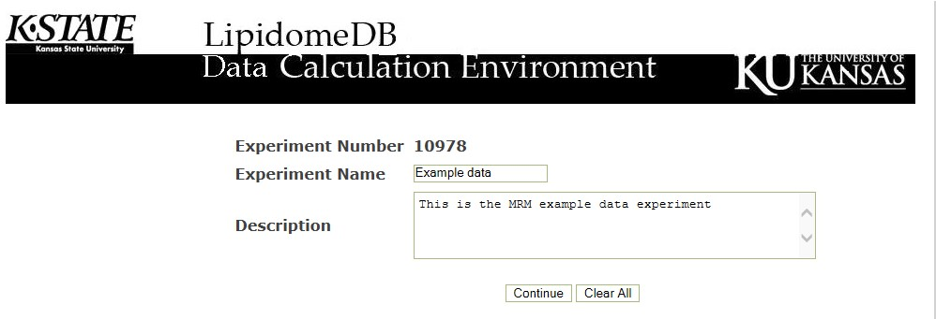

Step 4: Upload the data: Upload the data in an Excel file in the format described in Section 2E and illustrated in the MRM example data upload file. Click Continue.

Step 5: Collect the results: A large data table appears on the screen. The output data appear directly to the right of the Input intensities in the same units as the internal standards (typically nmol). They are labeled with the sample names indicated by the user. In columns P and Q, the calculated Intact ion m/z output from chemical formula and adduct information and Charged fragment ion m/z output from chemical formula will appear. If these are different from the data acquisition values in columns N and O, which generally would indicate a problem with the acquisition values or the formulas entered in the uploaded data, there is a warning at the top of the page.

At the bottom there is a button to Export to Excel. Pressing this button for the example data will create the MRM example data output file. However, any warnings from the LipidomeDB DCE are not exported. (You may want to compare columns N and O with P and Q, just to make sure they are the same or very similar.)

5. USE OF LIPIDOMEDB DCE FOR CID-TOF DATA

Step 1: Assemble the data to be entered: The required information and format is described in Section 2F. The file needs to be prepared just like the CID-TOF example data upload file. This example file contains CID-TOF MS data for 10 samples (Wounded-45-1, Wounded-45-2, Wounded-45-3….Wounded-45-10), which are lipid extracts from Arabidopsis that do not contain an internal standard. (You may add internal standard(s) to CID-TOF samples if desired, as described above in Section 2B.)

Step 2: User log-in: Please log in if you know your ID/password. Please contact us by emailing David Johnson if you want to create an account in the system or if you forgot your ID/password. After logging in, select Add CID-TOF Experiment. Information on the Add Precursor/Neutral Loss Experiment choice is in Section 3. Information on the Add MRM Experiment choice is in Section 4. Information on the Add or Edit Fragments, Add or Edit Compounds, Edit User-Saved Precursor/Neutral Loss Target Lists, and Add or Edit CID-TOF Interfaces choices is in Section 6.

Step 3: Enter data about the experiment: As seen in the screenshot shown below, an experiment number is assigned by the database. Enter an experiment name and a description of the samples. Mass Tolerance defines the m/z window for peak searching. We recommend 0.004 (mass units, u); this setting will locate peaks within 0.004 u above and below the theoretical m/z value for the designated target fragment ion. Mass to find provides for three options, Find the Nearest Mass (nearest to the theoretical m/z value of the designated target fragment ion), Find the Largest Signal (within the m/z window designated by mass tolerance setting), and Find the Sum of all Signals (a sum within the m/z window designated by mass tolerance setting). For CID-TOF MS data sets, we suggest choosing Find the Nearest Mass. Click Continue.
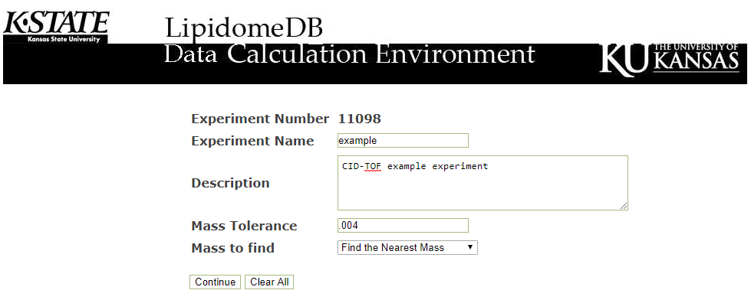

Step 4: Enter the target fragment list: The user can enter target fragments or choose an existing list.

a. Enter a target fragment set from an existing (pre-formulated) list: The existing lists include a list of fatty acyl anions suitable for analysis of lipids derived from many plants and animals, called “fatty1” (see screenshot below). If you are using the example data, choose “fatty1”.
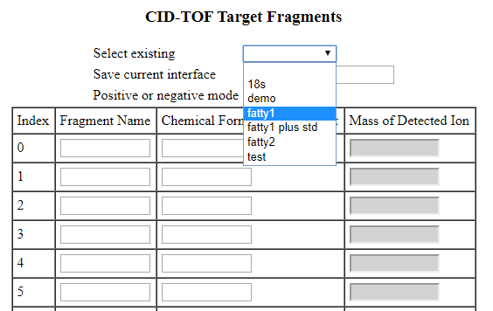

When you choose an existing list, a new page will appear. See the screenshot below. Be patient and wait a few seconds for this sheet to appear before moving on.

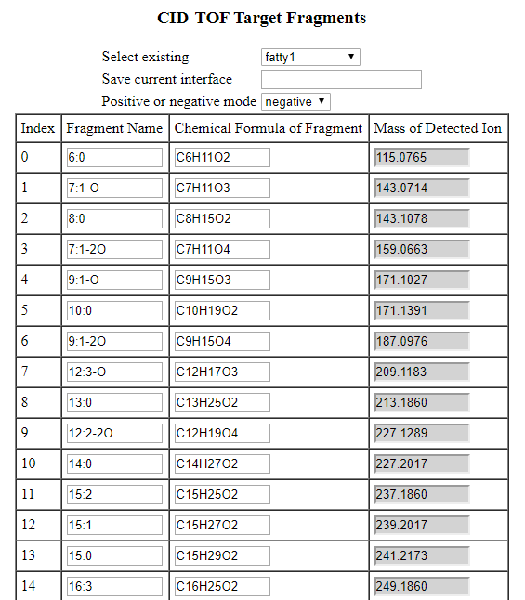

Please note: You can modify the existing CID-TOF target fragment lists. You cannot save them with the original name, but you can save them with a new name so that they will be available to you (but not to other users) in the future. Added target compounds can be added at the end of the list and do not need to be in any particular order.

Scroll to the bottom of the page and press Continue. If using an existing (pre-formulated) list, go to Step 5.

b. Enter your own target fragment set: You may indicate fragments by typing in an existing fragment name (which will retrieve the proper fragment formula). You also may add your own fragments by entering them right after log-in via the Add or Edit Fragments feature (see Section 6). If the fragment contains atoms that are added during formation of an adduct ion, these atoms need to be included in the fragment formula. Fragments derived from any internal standards should be included in the target fragment list.

Target fragments do not need to be listed in any particular order. If a fragment is in the database (LipidomeDB), typing its abbreviation under Fragment Name will retrieve the associated chemical formula. If a fragment is not in the database, entering the chemical formula and associated name is required. Elements that can be interpreted are C, H, N, O, P, and S. Chemical formulas should be entered as CmHnOqNrPsSt, where the large letters represent the elements and the small letters indicate the number of atoms of each element. Leaving an element abbreviation out of the formula indicates 0 atoms of that element, and no number following the element abbreviation indicates 1 atom of that element. The Mass of Detected Ion will calculate automatically when the chemical formula is retrieved or entered.

Give the CID-TOF Target Fragments list a name, in the box near the top called Save current interface, so that the target data list will be available to you (but not to other users) in the future.

Please note: You can modify the existing lists. You cannot save them with the original name, but you can save them with a new name.

When you have completed entering CID-TOF Target Fragments, scroll to the bottom of the page and press Continue. Go to Step 5.

Step 5: Upload the input data generated from the experiments in Excel format: The following is the screenshot of the page used to upload the files.

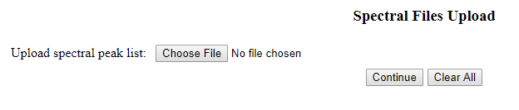
Choose the proper Excel data file in the specified format. Once selected, the filename will appear on the screen. The screenshot after selecting the example data file is shown below.

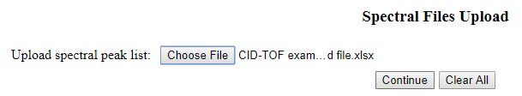

Press Continue.

Step 6: Collect the results: After the analysis is performed, the results can be viewed as a summary of the intensities of each target fragment on the screen or in an Excel file that can be downloaded. The following screenshot shows an example of the top of the results page. To download the results, go to the bottom of the results table and click on the Export to Excel button. If you uploaded the example file, your output file should look like this.

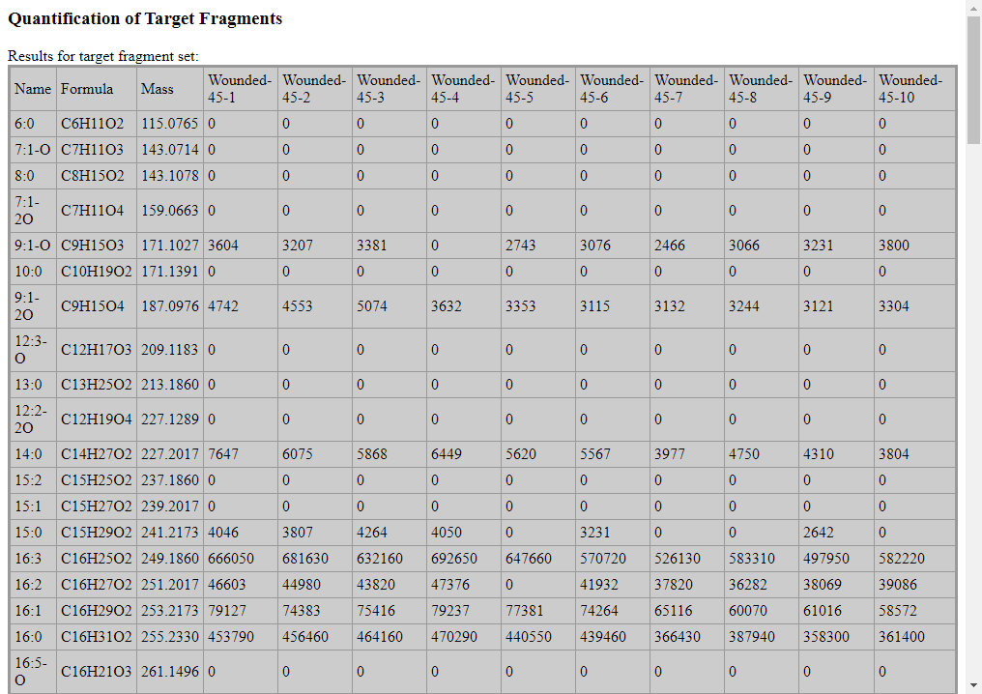

The intensities of the target fragments are collected in the table. The table above shows fatty acyl anion fragments. If one of these is an internal standard (i.s.), you could calculate the levels of the other fatty acyl fragments in each sample in relation to the i.s. by the following:

nmol of target fragment = (intensity of target fragment) x (nmol i.s. target fragment) / (intensity of i.s. target fragment)

If the i.s. has two identical target fragments (e.g., two identical fatty acyl chains), “nmol i.s. target fragment” in the above formula should be double the i.s. concentration.

If you would prefer to get the composition of the fragments as a percent of the total intensities, you can calculate as follows:

% of target fragment = (intensity of target fragment) x 100 / (sum of target fragment intensities)

The sum of target fragment intensities should not include any intensities of internal standards.

6. THE COMPOUND AND FRAGMENT DATABASES AND EDITING OF SAVED TARGET LISTS

Add or Edit Fragments and Add or Edit Compounds (choices on the page after the log-in page) can be used if you plan to perform an analysis using fragments (for Pre/NL, MRM, and CID-TOF analyses) and/or compounds (for Pre/NL and MRM analyses) that are not in the database. The already-entered fragments and compounds are listed by names and formulas on the drop-down tabs. The beginning of the fragment and compound lists have the default fragments or compounds (greyed-out), and the user-entered fragments or compounds follow these. Choosing either the name or formula drop-down brings up equivalent information on the other drop-down. To enter a new compound or fragment, type the name(s) and formula(s) into the boxes provided or follow the on-page directions to copy from the pull-downs. Alternatively, you can copy and paste two columns (names and formulas) from Excel into the box at the bottom of the page, and use the Fill Boxes button to generate the list to be added. Click Add Fragments or Add Compounds. You can delete fragments or compounds that you have entered by entering the name with the formula box blank. (Details on interpretation of typed formulas are under Section 3, Step 4b.)

You can edit Target Lists that you have saved by using the Edit User-Saved Precursor/Neutral Loss Target Lists or the Add or Edit CID-TOF Interfaces page available from the page after the log-in page. After making changes in the Edit User-Saved Precursor/Neutral Loss Target Lists page, it’s a good idea to press Recalculate All at the bottom of the page before pressing Save. Recalculate All calculates the a₁ and a₂ values, taking the adduct and fragment values into account.

7. OTHER CONSIDERATIONS ABOUT THE DATA

7A. Inclusion of tissue metrics and other adjustments for Pre/NL or MRM data:
Once the Results are exported to Excel, one can correct for chemical or instrumental noise in the samples by subtracting the molar amount of each lipid metabolite detected in the spectra of the “internal standards only” samples from the molar amount of each metabolite calculated in each set of sample spectra. The data from each “internal standards only” set of spectra can be used to correct the data from the following 10 samples. Then, the concentration per amount of sample can be calculated. Generally the molar (nmol) data produced by LipidomeDB DCE is divided by some tissue metric, such as weight of the sample or amount of protein in the sample. If the internal standard mixture was not added to the entire original sample, but to a fraction of the extract (to conserve internal standards), the Results will also need to be divided by that fraction to get the amount in the entire sample.

7B. About the quantification for Pre/NL or MRM data:
For very polar compounds, such as phospholipids, the various molecular species within a class, e.g., the various PC molecular species, ionize with similar efficiencies [Han and Gross, 2005]. Therefore, for polar lipids, the procedures outlined above result in accurate quantification. The results can be reported in the molar amounts that are returned by the calculations.

However, for certain classes of compounds, and particularly for less polar lipids, molecular species within a target group may vary in response, based on the structural features specific to the individual compounds, such as the presence of double bonds. An example of a group of lipids with molecular species that vary considerably in mass spectral response is triacylglycerols [Han and Gross, 2001]. A second example of target groups with individual molecular species that may vary in response are SMs and PCs, measured in the same scan for a phosphocholine fragment (i.e.., positive Pre184). A third example are target groups that contain lipid species with both ether and ester linkages (e.g., alk(en)yl,acyl and diacyl glycerolipids). And, for many groups of compounds, the responses of particular target lipid species with respect to internal standard responses are simply unknown, and standards for the target compounds are not available [e.g., Maeda et al., 2008].

There are two approaches to dealing with data in which the molar results reported may not accurately reflect the molar amounts of specific compounds. One approach is to correct the data for the varied responses. The other approach is to report the results as “corrected normalized mass spectral signal”. Correction for the varied responses generally requires that purified standards of known concentration are available so that response factors for the target compounds can be determined. Correction of data with variation in response factors is described by Liebisch et al. [2004] for the PC and SM groups of lipids. If the response of SM species in comparison to PC species of the same mass is experimentally determined, SM values calculated by LipidomeDB DCE may be divided by the response factor to determine SM accurately. Jao et al. [2009; supplemental data] reported a value of 0.39 for the response of SM compared to the response for the same molar amount of PC. Correction of specific triacylglycerol molecular species signals in relation to the responses of standards was described by Han and Gross [2001].

For target groups of compounds that vary or may vary in response, and for which it is not practical or desired to obtain response factors for individual molecular species, it is suggested that the molar (“nmol”) data calculated by LipidomeDB DCE be reported as “corrected normalized mass spectral signal”. Here, “corrected” refers to (1) the isotopic deconvolution and (2) the correction for m/z response that is performed in comparing the signal to that of the internal standards, if two or more internal standards are used for the target group. “Normalized mass spectral signal” refers to normalization of the target lipid signal to the internal standard signal(s) in each sample. A value of “corrected normalized mass spectral signal” of 1 means that the target compound generates signal equal to the signal of 1 nmol of the internal standard compound(s). Reporting of “corrected normalized mass spectral signal” allows for inter-sample comparisons of the amounts of particular molecular species; for many purposes these data are quite adequate.

7C. About the quantification for CID-TOF data:
A discussion of limitations on the quantification of fatty acyl anions identified by CID-TOF MS can be found in Esch et al. [2007].

8. ABOUT THE FUNCTION OF LIPIDOMEDB DCE (TECHNICAL INFORMATION)

8A. Languages:
LipidomeDB DCE supports a web interface with a database backend and scripts to read and perform calculations on data in Excel format (.xls for Pre/NL calculations, .xls or.xlsx for MRM calculations, .xlsx for CID-TOF calculations). LipidomeDB DCE is based in JSP. The user interface is designed in JSP with Javascript used to perform client-side computations, such as those related to isotopic abundances, and Java used for server-side data analysis, such as searching the database for target lipid species matching uploaded data with the target species lists, and isotopic deconvolution.

8B. Target lipid masses and isotopic variant fractions:
The mass of the lipids and the a₁ and a₂ fractions are calculated for the lipid molecular species in each Target Compound Set from the chemical formulas. This is relevant for the Pre/NL and MRM analyses. For each target compound or internal standard, the (neutral) mass, M, is the sum, for all elements present, of the [number of atoms of the element] x [the mass of the most abundant isotope of the component element]. The m/z of the chosen adduct ion (Mass of Detected Ion) is determined by adding or subtracting the appropriate atoms/ions to/from the mass of the neutral compound. Elements that can be entered in target compound and internal standard formulas are shown in Table 6.

Table 6: Elements used in LipidomeDB DCE, their masses, and relevant isotopic abundances
Data here is based on that at
http://www.sisweb.com/referenc/source/exactmas.htm

Element | Mass (u) of most abundant isotope | Isotopic abundances used in calculating a₁ and/or a₂.  Abundances are compared to most abundant isotope (= 1)
C | 12.0000 | ¹³C: 0.0111223
H | 1.0078 | ²H: 0.000150002
N | 14.0031 | ¹⁵N: 0.00371374
O | 15.9949 | ¹⁷O: 0.000380914 | ¹⁸O: 0.00200481
P | 30.9738
S | 31.9721 | ³³S: 0.00789308 | ³⁴S: 0.0443065
Na | 22.9898

For the Pre/NL analyses, in each sheet called Target Compound Set, a₁ and a₂, the isotopic abundances of the first and second isotope peaks for each compound, are calculated based on the formula of each target and internal standard compound. The factors a₁ and a₂ represent the size of the A+1 and A+2 peaks, respectively, in relation to the main (A) peak for each compound. In the Pre/NL analysis, a₁ and a₂ values are calculated using the following formulas:

a₁ = (0.0111223)(tC –fC) + (0.000150002)(tH – fH) + (0.00371374)(tN – fN) + (0.000380914)(tO – fO) + (0.00789308)(tS – fS)
a₂ = [(0.0111223)(tC –fC)]²/2 + (0.00200481)(tO – fO) + (0.0443065)(tS – fS)

where tC, tH, tN, tO, and tS represent the number of C, H, N, O, and S atoms in the analyzed adduct ion and fC, fH, fN, fO, and fS represent the number of C,H, N, O, and S atoms in the precursor or neutral loss fragment. The constants represent the natural abundances of the relevant heavier isotopes in relation to the abundances of the most abundant isotope. The fragment mass is excluded from the chemical formulas used to calculate the a₁ and a₂ values, because the fragment portion of the ion is fixed by the scan; ions with isotopic variation in the fragment portion are not analyzed.

For the MRM analyses, an equivalent, but slightly different, algorithm is used for a₁ and a₂ values. Isotopic abundances are employed to calculate the probability of a spectral peak with no minor isotopes (the a₀ peak), the probability of a spectral peak with one isotope with 1 additional mass unit (the a₁ peak), and the probably of a peak with either one isotope with 2 additional mass units or two isotopes each with 1 additional mass unit (the a₂ peak). The probabilities for each peak are divided by the value for the a₀ peak to give fractional values for a₁ and a₂ very close to those used in the Pre/NL analysis algorithm.

8C: Data analysis algorithms for Pre/NL analysis:
The Pre/NL analysis algorithm has three parts: Lipid search, Isotopic deconvolution (correction) of signal, and Amount calculation.

Lipid search: The peaks corresponding to the specified adduct ions of the internal standards and target lipids are located in the input data by m/z (here designated as “mass”), and the value of each corresponding signal is collected. Any mass that is within the specified mass tolerance window (specified compound mass ± the mass tolerance) is considered a candidate mass for the specified target lipid or internal standard. The search algorithm provides three options for the user on the experiment creation page, in case multiple masses are found within the mass tolerance window. The three options are:
Nearest Mass: The m/z closest to the lipid ion’s m/z is selected.
Highest Signal: The m/z having the highest corresponding signal value is selected.
Sum of Signals: All signals of the candidate peaks (those within the specified mass tolerance target window) are summed.
If a target lipid m/z is not found, its signal is considered to be zero.
If the m/z of any one of the standards is not found, an error message appears in the sheet that opens after pressing “Get Results for Sample x”; data for this target list will all be quantified as 0 or not calculated at all.

Note to Advanced Users: If you checked the box “Check here if the standards are in a separate spectrum from target compounds.”, standards will be found in the second set of spectra uploaded.

Isotopic deconvolution (correction) of signal: After the signals for each compound in each target group are established, the next step is to deconvolute intensities (signals) due to isotopic overlap of peaks for various targeted compounds (i.e., both target and internal standard compounds). This step is necessary because (1) significant isotopic abundances of higher mass isotopes, particularly ¹³C, ¹⁵N, ¹⁸O, and ³⁴S, mean that each lipid compound produces a multi-peak spectrum with a peak at the predicted target m/z (the “A” mass), and additional peaks at higher m/z, particularly at the “A+1” and “A+2” masses, at the nominal mass resolution obtained with a triple quadrupole mass spectrometer, and (2) there are many cases of lipids with m/z ~1 and 2 units apart, sharing a common fragment, and thus analyzed in the same target lipid scans. Lipids with m/z ~2 units apart are common and typically vary in unsaturation (i.e., numbers of carbon-carbon double bonds). Lipids that share a common fragment and have m/z only ~1 unit apart include certain SM and PC molecular species. These species share a common phosphocholine fragment and are both detected in a positive Pre184 scan. When spectral peaks are close in m/z and the peaks are resolved only to nominal mass, then, in order to identify the signals corresponding to particular target compounds, the signals of the higher mass peaks in a cluster (defined as a series of peaks where adjacent peaks differ by 1 or 2 m/z) must be corrected by subtracting the contribution due to the isotopic variants of the lower mass peaks in the cluster. LipidomeDB DCE performs A+1 and A+2 corrections.

For each compound, the algorithm identifies other targeted or standard compounds that are within one (>0.5 and <1.5) or two (>1.5 and <2.5) mass units (m/z). When these are located, the algorithm performs a correction that removes signal, due to a₁ and a₂ peak signal values from lower mass targeted peaks, from targeted peaks with greater mass. Starting at the lowest m/z peak in a cluster, the algorithm uses the following formulas:

Peak | Calculated (corrected) peak intensity
B where B = m/z of lowest-m/z peak in the cluster | I_{C(B)} = I_{M(B)}
B+1 (targeted peak at m/z = B + 1 m/z) | I_{C(B+1)} = (I_{M(B+1)}) – (a_{1(B)})(I_{C(B)})
B+2 (targeted peak at m/z = B + 2 m/z) | I_{C(B+2)} = (I_{M(B+2)})– (a_{1(B+1)})(I_{C(B+1)}) – (a_{2(B)})(I_{C(B)})
B+3 (targeted peak at m/z = B + 3 m/z) | I_{C(B+3)} = (I_{M(B+3)}) – (a_{1(B+2)})(I_{C(B+2)}) – (a_{2(B+1)})(I_{C(B+1)})
B+4 (targeted peak at m/z = B + 4 m/z) | I_{C(B+4)} = (I_{M(B+4)}) – (a_{1(B+3)})(I_{C(B+3)}) – (a_{2(B+2)})(I_{C(B+2)})
etc.

where a_{1(x)} and a_{2(x)} are the values of a₁ and a₂ for peak x, I_{C(B)} is the calculated (isotopically corrected) intensity (signal) for peak x, and I_{M(B)} is the measured (uncorrected) intensity for peak x. For peak m/z not included in the target list, a₁ and a₂ are considered to be 0.

Note to Advanced Users: If you checked the box “Check here if the standards are in a separate spectrum from target compounds.”, then no isotopic deconvolution will be performed on the spectrum containing the standards. The peak intensities of the standards from the separate spectrum will be used directly in the amount calculation. The target compounds will be isotopically deconvoluted among themselves as described above.

Amount calculation: After the corrected peak signals are established, the amount of each lipid is calculated. These amounts depend on the signal values for the internal standards and the corresponding internal standard amounts the user has specified. Because the mass spectrometer response for specific amounts of material can vary with the m/z of the compounds, the first step is to construct a plot of signal vs. m/z and to draw a line through the signal data for a set amount of each related standard compound. This procedure is performed on the internal standards for each set of target compounds. Then for each target list of lipids, the corrected signal values are compared to the standard line to calculate the amount of each compound analyzed. See also the section entitled About the quantification for Pre/NL or MRM data (Section 7B).

Note to Advanced Users: If you checked the box “Check here if the standards are in a separate spectrum from target compounds.”, then the standards used to draw a line will be the standards in the second set of uploaded spectra.

First, the internal standard signal data are adjusted, if necessary, so that all signal values represent the same amount of internal standard compounds, i.e., I_{C(S2)}ª = (I_{C(S2)})(molar amount of S1/molar amount of S2) and I_{C(S3)}ª = (I_{C(S3)})(molar amount of S1/molar amount of S3), where S1, S2, and S3 are internal standards 1, 2, and 3, respectively, and I_{C(S2)}ª and I_{C(S3)}ª are the adjusted, isotopically corrected signals for internal standards 2 and 3.

The corrected (S1) and adjusted and corrected (S2 and S3) signals are plotted vs. the internal standard m/zs. The data are fitted with a straight line. If there is only one internal standard, the straight line is
y = I_{C(S1)}, where I_{C(S1)} is the isotopically corrected signal for the standard (S1).
If two or three internal standards are used, the internal standard signal data are fitted with a line between the two standards, or the best straight line (least squares fit) between the three standards, and the formula for the trend line is obtained. In each case, the straight line represents the expected, corrected signal for compounds at various m/z for the amount of S1 used.

To determine the amount of the target compounds, the isotopically corrected intensity (signal) for each target compound R, I_{C(R)}, is compared to the y value (i.e., signal value) for the line or trend line at the x (i.e., m/z value) associated with that target compound ion.
The amount of target compound R = (I_{C(R)})(molar amount of S1)/(I_{TR}), where I_{TR} is the signal value for the line or trendline at the target compound m/z.

If the units for the amount of S1 used are nmol, then the data are presented in nmol. These data are the Results of LipidomeDB DCE.

8D. Data analysis algorithm for MRM analysis:

The MRM deconvolution algorithm: This algorithm indexes the data in the rows of the MRM data upload file by the DMS name and by intact ion m/z and fragment m/z within each DMS group. Only the analytes within a DMS group are considered for deconvolution from each other. Additional arrays are made for collection of deconvoluted data and quantified data.

The algorithm moves through analytes in each DMS group "looking back" in the data sheet and checking for other compounds with an intact ion m/z of 1 mass unit less than the analyte’s intact ion m/z and fragments either 0 or 1 m/z less than the analyte’s fragment m/z, and also for compounds with an intact ion m/z of 2 mass units less than that of analyte’s intact ion m/z and fragment m/z of 0, 1, or 2 mass units less than the analyte’s fragment m/z, as shown below.

Charged fragment m/z (in nominal mass)
Intact ion m/z (in nominal mass)
 | Intact ion m/z 2 u less, Charged fragment is 2 u less
 | Intact ion m/z 2 u less, Charged fragment is 1 u less | Intact ion m/z 1 u less, Charged fragment is 1 u less
 | Intact ion m/z 2 u less, Charged fragment the same | Intact ion m/z 1 u less, Charged fragment the same | Analyte  of interest

The algorithm then uses the data on the analytes identified in the “look back” for deconvolution of the analyte of interest. If there are previously deconvoluted data for those analytes found in the “look back”, those data are used in the calculation. The a₁ and a₂ values used in the calculations are for the charged fragments or the neutral pieces of the compounds as shown in the table below. The intensity of the analyte in each block is multiplied times the a1 and/or a2 values for the proper fragments (below) and subtracted from the intensity of the “Analyte of interest” to generate a deconvoluted value for the analyte of interest. If the result is <0, 0 is entered into the deconvoluted data array. The algorithm is propagated by stepping upward in mass (m/z) while always “looking back” in the already deconvoluted data and employing those data in the deconvolutions.

Charged fragment m/z
Intact ion m/z
 | Charged fragment a₂
 | Neutral piece a_{1 X} charged fragment a₁ | Charged fragment a₁
 | Neutral piece a₂ | Neutral piece a₁ | Analyte  of interest

MRM Quantification: The deconvoluted data intensity for each analyte is normalized to the intensity of the appropriate deconvoluted internal standard(s) in line or average mode, as described in Section 2E (description of column M in the MRM data upload file).

8E. Data analysis algorithm for CID-TOF analysis:

The CID-TOF data analysis algorithm simply identifies a peak within the m/z window specified by the user for each target fragment. The algorithm can return the peak closest to the specified m/z, the largest peak in the window, or the sum of the peaks within the window, depending on the user’s choice. The algorithm outputs the identified intensity for each target fragment.

